**Exercise 2: E-commerce Platform Search Function**

**Scenario:**

You are working on the search functionality of an e-commerce platform. The search needs to be optimized for fast performance.

**Steps:**

1. **Understand Asymptotic Notation:**
   * Explain Big O notation and how it helps in analyzing algorithms.
   * Describe the best, average, and worst-case scenarios for search operations.
2. **Setup:**
   * Create a class **Product** with attributes for searching, such as **productId, productName**, and **category**.
3. **Implementation:**
   * Implement linear search and binary search algorithms.
   * Store products in an array for linear search and a sorted array for binary search.
4. **Analysis:**
   * Compare the time complexity of linear and binary search algorithms.
   * Discuss which algorithm is more suitable for your platform and why.

**SOLUTION:**

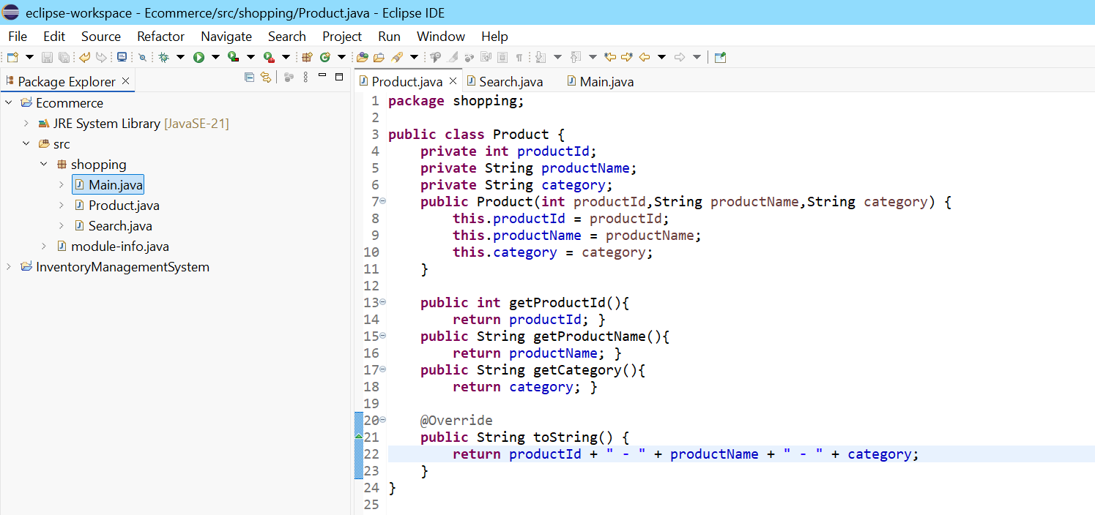

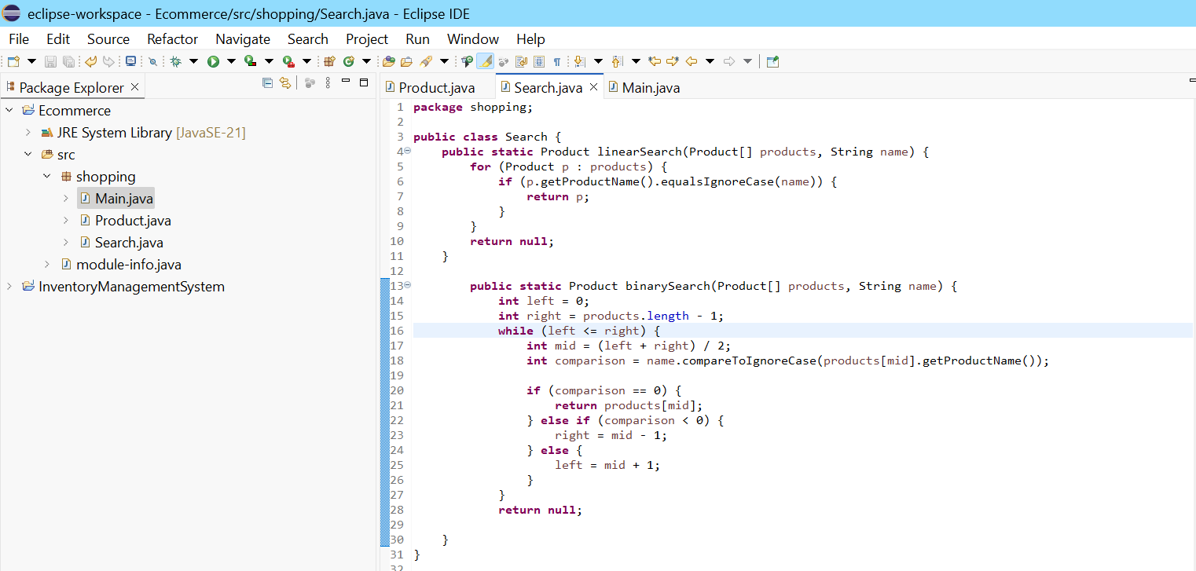

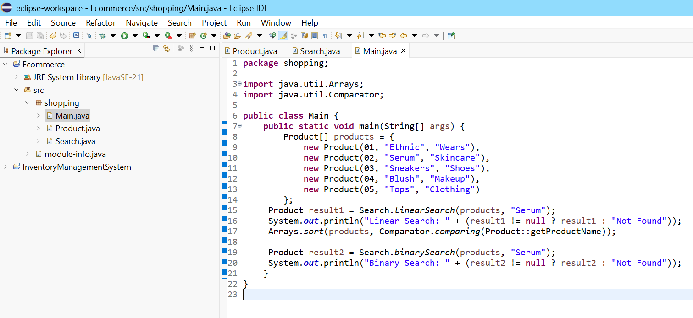

**OUTPUT:**

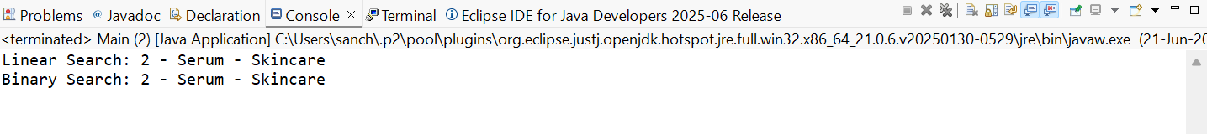

**Explain Big O notation and how it helps in analyzing algorithms.**

Big O Notation is a mathematical way to describe the efficiency of an algorithm, especially in terms of time complexity and space complexity as input size grows.

Why Big O is Important:

* It helps predict performance.
* Lets us compare algorithms regardless of hardware.
* Focuses on the worst-case scenario, ensuring reliability.

**Describe the best, average, and worst-case scenarios for search operations.**

* Linear Search (O(n))
* Best Case:
  + Target is the first element

Time: O(1)

* Average Case:
  + Target is somewhere in the middle

Time: O(n/2) ≈ O(n)

* Worst Case:
  + Target is the last element or not found

Time: O(n)

* Binary Search (O(log n)) – on sorted data
* Best Case:
  + Target is the middle element

Time: O(1)

* Average Case:
  + Repeatedly divide the list

Time: O(log n)

* Worst Case:
  + Target not found or at far end

Time: O(log n)

**TIME COMPLEXITY:**

**Linear Search** : Best Case– O(1)

Worst Case-O(n)

**Binary Search** : Best Case– O(1)

Worst Case-O(logn)

**Which algorithm is more suitable for my platform and why?**

Binary Search,as it is efficient for faster search.